INFOSYS SPRINGBOARD VIRTUAL INTERNSHIP 6.0

FOOD TRENDS
UNDERSTANDING CUSTOMER PREFERENCES

Group-1, Batch - 11, TEAM – A
Mentor: Ms. Nityasree

TEAM MEMBERS:
Abhinit Kumar
Lekhana S.R
Harshini Ganesan
Jai Akash L J

1. Project Title
Food Trends – Understanding Customer Preferences

2. Project Objective
The main objective of this project is to analyze customer food ordering behavior and preferences using data visualization techniques.
This project aims to understand how customer demographics, food choices, ordering platforms, service quality, and external factors influence food ordering decisions. By using interactive Power BI dashboards, the project helps derive meaningful insights that can support restaurants and food delivery platforms in improving customer satisfaction and business performance.

3. Project Description
3.1 Overview
The Food Trends – Understanding Customer Preferences project focuses on analyzing food ordering data collected through a structured dataset. The dataset contains customer details, restaurant information, order behavior, service experience, and external influencing factors.
Using Power BI, multiple dashboards were created to visually represent patterns and trends in customer behavior. These dashboards help in understanding what customers prefer, when they order food, which platforms they use, and what factors influence their decisions.

3.2 Project Approach
The project followed a systematic and milestone-based approach:
- Understanding the dataset structure and attributes
- Cleaning and preprocessing raw data
- Categorizing data into logical domains
- Creating DAX measures for KPIs
- Designing interactive dashboards in Power BI
- Analyzing insights from each dashboard
This structured approach ensured accuracy, clarity, and meaningful business insights.

3.3 Technology Used
- Power BI Desktop – Data modeling, visualization, dashboard creation
- Power Query – Data cleaning and transformation
- DAX (Data Analysis Expressions) – Calculated measures and KPIs
- Excel / CSV – Dataset storage and handling

3.4 Insights from the Dashboard
Key insights derived from the dashboards include:
- Young customers and students form the largest customer segment
- Taste, food quality, and freshness strongly influence customer satisfaction
- Vegetarian food is preferred by a majority of customers
- Direct call ordering is still widely used along with online platforms
- Ratings, discounts, and accurate location details influence customer decisions
- Lunch and snack times are peak ordering periods
These insights help businesses improve menu planning, service quality, and promotional strategies.

3.5 Real-World Impact for Media and Public Communication
This project demonstrates how data visualization can be used to communicate complex customer behavior in a simple and effective way.
Media and businesses can use such dashboards to:
- Understand changing food trends
- Communicate customer preferences visually
- Support data-driven storytelling
- Improve transparency and decision-making

4. Timeline Overview
The project was completed in multiple phases, starting from data understanding to final dashboard analysis. Each phase was aligned with internship milestones to ensure timely completion and quality output.
Milestone | Activity Description | Date
Milestone 1 | Data understanding and preprocessing | 9 January 2026
Milestone 2 | Dashboard development (Customer Profile, Food Preference, Ordering Patterns) | 23 January 2026
Milestone 3 | Service quality analysis and customer decision factors dashboards | 30 January 2026
Milestone 4 | Restaurant performance, promotions analysis, final review and reporting | 6 February 2026

5a. Key Milestones
Milestone | Description
Milestone 1 | Data understanding and preprocessing
Milestone 2 | Development of first three dashboards
Milestone 3 | Development of dashboards focused on service quality and decision factors
Milestone 4 | Final dashboards on restaurant performance and promotions

5b. Project Execution Details
- Dataset cleaning and transformation using Power Query
- KPI creation using DAX
- Dashboard design with consistent layout and theme
- Validation of insights across dashboards
- Documentation and reporting

6. Snapshots / Screenshots
6.1 Page 1: Customer Profile Intelligence
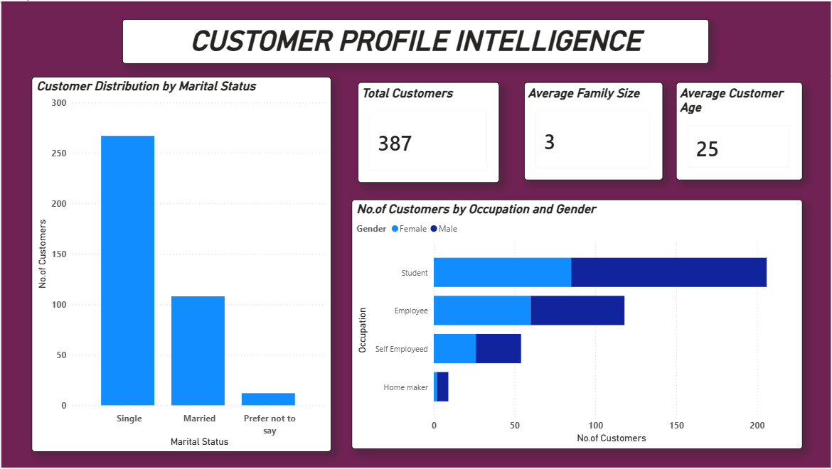
Screenshot showing customer demographics, age, family size, and occupation.
6.2 Page 2: Order & Food Preference Analysis
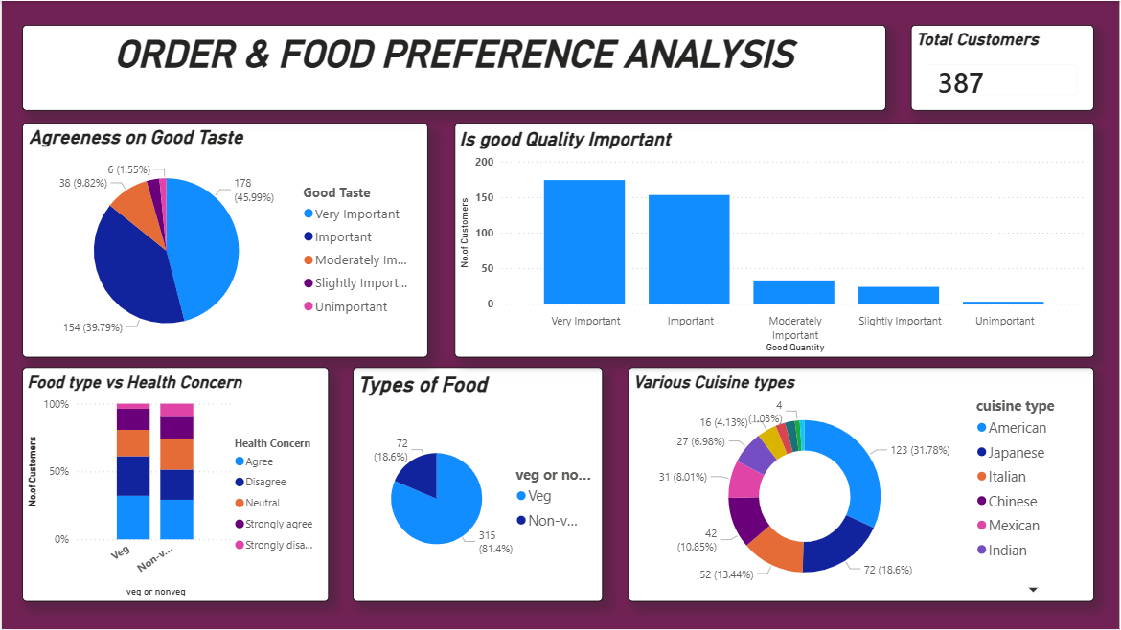
Screenshot showing food type, cuisine preference, taste, and quality analysis.
6.3 Page 3: Ordering Patterns & Platform Behaviour
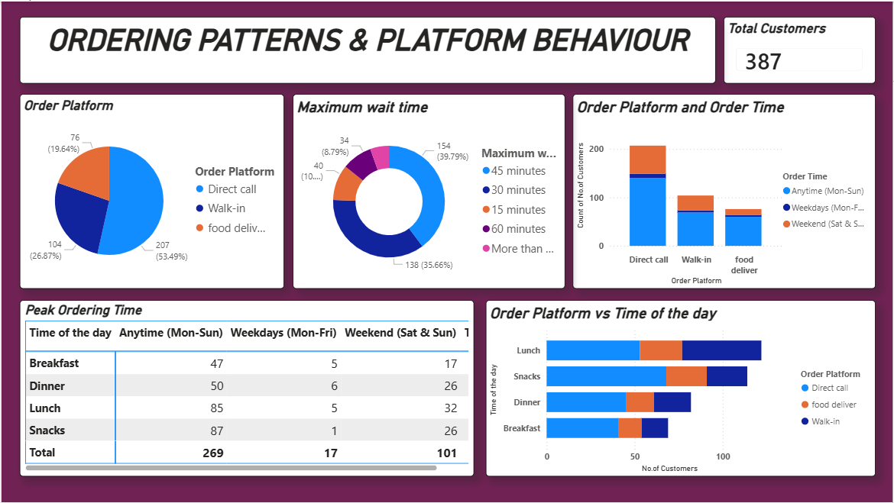
Screenshot showing order platforms, waiting time, and peak ordering periods.

6.4 Page 4: Delivery Experience & Service Quality
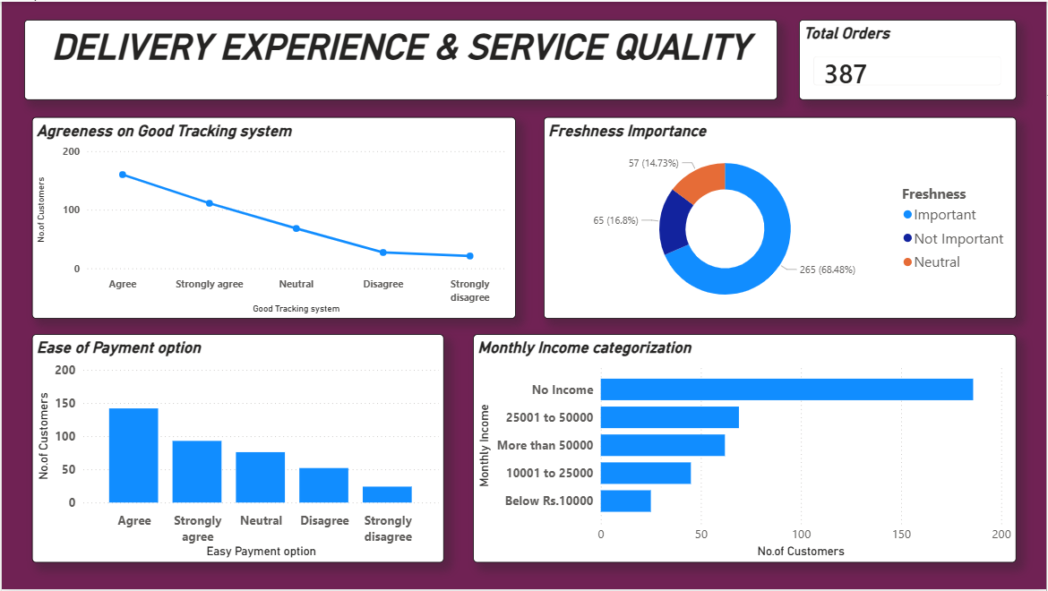
Screenshot showing tracking system, freshness, payment ease, and income categories.
6.5 Page 5: Customer Decision & Influence Factors
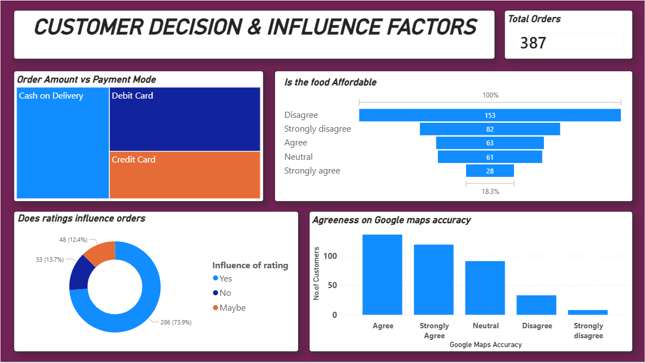
Screenshot showing affordability, ratings influence, payment mode, and Google Maps accuracy.
6.6 Page 6: Restaurant & Cuisine Performance Insights
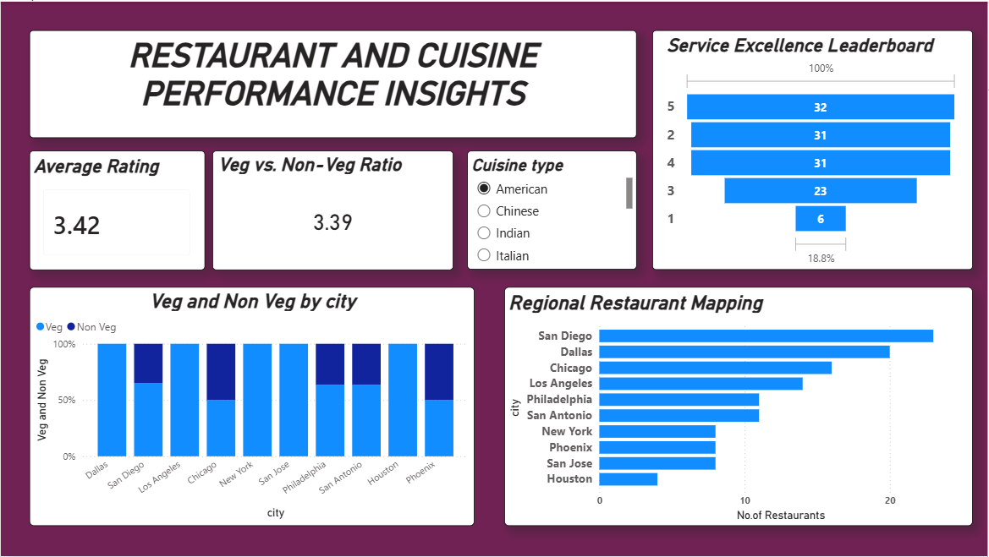
Screenshot showing ratings, veg/non-veg ratio, city-wise analysis, and leaderboard.
6.7 Page 7: Promotion, Time & External Impact Analysis
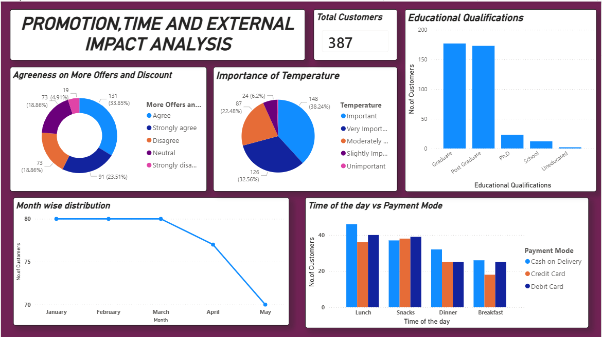
Screenshot showing offers, temperature impact, education level, and payment timing.

7. Challenges Faced
7.1 Data Cleaning Challenges
- Inconsistent category labels (Veg/Non-Veg, rating levels)
- Power BI Service does not support true parallel dashboard editing, making team collaboration difficult
- Each update required publishing and pulling the latest version from the cloud
- Missing or unclear survey responses
Resolution:
- Adopted a sequential editing workflow for Power BI dashboards.
- Assigned clear responsibility for report updates to avoid conflicts.
- Standardized values using Power Query and handled missing data carefully.

7.2 Visualization Challenges
- Managing multiple dashboards with consistent KPIs
- Avoiding overcrowded visuals
Resolution:
Used slicers, clean layouts, and milestone-wise dashboard creation.

8. Learnings & Skills Acquired
8.1 Technical Skills
- Data cleaning and preprocessing
- Power BI data modeling
- DAX calculations
- Dashboard design

8.2 Analytical and Problem-Solving Skills
- Identifying trends and patterns
- Converting raw data into insights
- Business-oriented data interpretation

8.3 Soft Skills and Team Collaboration
- Team coordination and communication
- Time management
- Presentation and documentation skills

8.4 Domain Knowledge and Application
- Understanding food industry trends
- Customer behavior analysis
- Service quality and decision factors
- Understanding F&B marketing using the 4 Ps framework
  - Product: Veg and Non-Veg food preferences
  - Price: Affordability and spending behavior
  - Place: Online food ordering platforms
  - Promotion: Impact of ratings and reviews

9. Testimonials from Team
Team members actively collaborated throughout the project, sharing insights, validating results, and supporting each other in dashboard development and analysis. The teamwork helped ensure accuracy and quality in the final output.

10. Conclusion
The Food Trends – Understanding Customer Preferences project successfully analyzed customer behavior using Power BI dashboards.
The project provided valuable insights into customer demographics, food preferences, ordering patterns, service quality, and decision-making factors. These insights can help businesses improve customer satisfaction, optimize operations, and make data-driven decisions.

11. Acknowledgements
We would like to express our heartfelt gratitude to:
- Infosys Springboard Team – for organizing this valuable internship opportunity
- Our Mentor (Ms. Nityasree) – for continuous guidance, support, and feedback
- My Teammates– for collaboration, encouragement, and valuable insights
This internship has been a significant step in our professional growth and technical journey.

Thank You

